Come Celebrate our New Light

Thursday, November 20

5:30 p.m.

All are welcome!

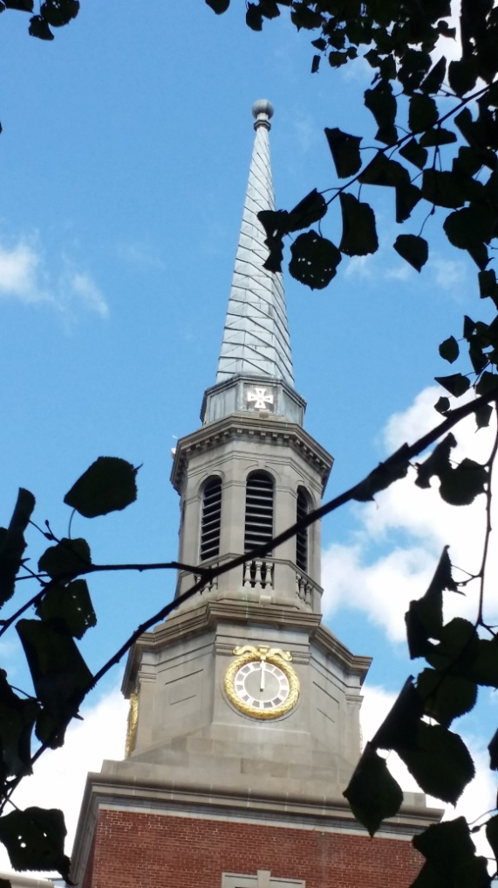

Join friends, neighbors, and members of
The New York Avenue Presbyterian Church
to celebrate the exciting results
of recent exterior renovations

The New York Avenue Presbyterian Church
1313 New York Ave., NW, Washington, DC 20005
(202) 393-3700 ~ www.nyapc.org

